

**SIMATS SCHOOL OF ENGINEERING**

**SAVEETHA INSTITUTE OF MEDICAL AND TECHNICAL SCIENCES**

**CHENNAI-602105**

**Gym Management System**

**A CAPSTONE PROJECT REPORT**

*Submitted in the partial fulfillment for the award of the degree of*

**BACHELOR OF ENGINEERING**

**IN**

**COMPUTER SCIENCE ENGINEERING**

**Submitted by**

**Aditya.K (192111130)**

**Nikhil.P (192211587)**

**Under the Supervision of**

**Ms.B.Jeevashri**

**JUNE 2024**

**DECLARATION**

We, **Aditya.K**, **Nikhil.P** students of **Bachelor of Engineering in Computer Science Engineering**, Department of Computer Science and Engineering, Saveetha Institute of Medical and Technical Sciences, Saveetha University, Chennai, hereby declare that the work presented in this Capstone Project Work entitled **Gym Management System** is the outcome of our own bonafide work and is correct to the best of our knowledge and this work has been undertaken taking care of Engineering Ethics.

Aditya.K 192111130

Nikhil.P 192211587

Date:

Place:

**CERTIFICATE**

This is to certify that the project entitled **“Gym Management System”** submitted by **Aditya.K, Nikhil.P** has been carried out under my supervision. The project has been submitted as per the requirements in the current semester of B. Tech Computer Science Engineering.

Teacher-in-charge

Ms.B.Jeevashri

**Table of Contents**

|  |  |
| --- | --- |
| **S.NO** | **TOPICS** |
|  | **Abstract** |
| 1 | **Introduction** |
| 2 | **Project Description** |
| 3 | **Problem Description** |
| 4 | **Tool Description** |
| 5 | **Operations** |
| 6 | **Approach / Module Description / Functionalities** |
| 7 | **Implementation** |
| 8 | **Result** |
| 9 | **Conclusion** |
|  | **References** |

**ABSTRACT:**

The Gym Management System website is a comprehensive platform designed to streamline the operations and interactions within a fitness center. Through a user-friendly interface built using HTML and CSS, the system caters to three main user roles: administrators, trainers, and members.For administrators, the system offers robust functionalities to manage the gym's resources efficiently. They can oversee membership registrations, update member profiles, and schedule classes or personal training sessions. Additionally, administrators have access to financial reports, enabling them to track revenue, manage expenses, and ensure financial health.Trainers benefit from tools that facilitate client management and session scheduling. They can view their daily schedules, update client progress, and communicate effectively through integrated messaging features. This allows trainers to focus more on delivering personalized fitness guidance and less on administrative tasks.Members experience a seamless journey from registration to achieving their fitness goals. They can easily sign up for memberships online, book classes or training sessions, and track their progress over time. The website provides a personalized dashboard where members can view their attendance history, upcoming sessions, and personalized workout plans tailored by their trainers.The design prioritizes usability and accessibility, ensuring a smooth experience across desktop and mobile devices. Clear navigation and intuitive interfaces make it easy for all users to access relevant information and perform necessary tasks efficiently.Security features protect user data and transactions, maintaining confidentiality and trust. Regular updates and maintenance ensure the system's reliability and performance, meeting the evolving needs of a dynamic fitness environment.The Gym Management System website incorporates advanced features to support growth and scalability for fitness centers of varying sizes. They can easily sign up for memberships online, book classes or training sessions, and track their progress over time. The website provides a personalized dashboard where members can view their attendance history, upcoming sessions, and personalized workout plans tailored by their trainers. Administrators can easily customize membership plans, promotions, and discounts to attract and retain members. Automated notifications keep members informed about upcoming classes, promotions, and changes to their schedules, enhancing communication and member engagement.Overall, the Gym Management System website not only enhances operational efficiency for administrators but also improves engagement and satisfaction for trainers and members alike, fostering a cohesive and thriving fitness community.

1. **INTRODUCTION:**

In today's fast-paced world, the fitness industry is witnessing a significant transformation driven by technology. The Gym Management System website represents a crucial innovation in this landscape, aiming to streamline operations and enhance user experience within fitness centers. Developed using HTML and CSS, this platform integrates functionalities tailored for administrators, trainers, and members, promising efficiency, engagement, and growth in the fitness community.The essence of the Gym Management System lies in its ability to centralize and automate various aspects of gym operations. For administrators, the system offers a comprehensive toolkit to manage memberships, schedule facilities, and track financial transactions. This not only simplifies administrative tasks but also provides critical insights through detailed reports and analytics, empowering decision-making and strategic planning. By digitizing these processes, the system reduces human error, improves efficiency, and ensures smoother day-to-day operations.Trainers benefit from tools designed to enhance client management and engagement. From scheduling sessions to monitoring client progress and communication, the system facilitates personalized training experiences. Trainers can access client profiles, update workout plans in real-time, and leverage analytics to optimize training methodologies. Such capabilities foster stronger relationships between trainers and clients, leading to better results and increased client satisfaction.For administrators, the system offers a comprehensive toolkit to manage memberships, schedule facilities, and track financial transactions.Members, the heart of any fitness center, experience a seamless journey facilitated by the Gym Management System. They can easily register for memberships online, book classes or personal training sessions, and track their fitness progress over time. Personalized dashboards provide insights into upcoming sessions, attendance history, and tailored workout plans, ensuring members stay motivated and committed to their fitness goals. The system's user-friendly interface, accessible via desktop and mobile devices, enhances convenience and accessibility, catering to the diverse needs of modern fitness enthusiasts.In summary, the Gym Management System website represents a pivotal advancement in how fitness centers operate and interact with their clientele. By leveraging technology to optimize administrative processes, enhance trainer-client relationships, and empower members in their fitness pursuits, the system sets a new standard for efficiency, engagement, and community-building in the fitness industry.

1. **PROJECT DESCRIPTION:**

**Overview:**

The Gym Management System project aims to develop a robust web-based application using HTML and CSS that facilitates efficient management of a fitness center. This system will cater to three main user roles: administrators, trainers, and members, providing each with tailored functionalities to enhance their experience and streamline operations.

**Key Features:**

**Administrator Dashboard:**

* **Manage memberships:** Admins can oversee member registrations, renewals, and cancellations.
* **Facility management:** Schedule gym facilities such as workout areas, studios, and equipment.
* **Financial management:** Track income from membership fees, personal training sessions, and other services. Generate financial reports for analysis and decision-making.
* **User management:** Add, update, or remove trainers and staff members.

**Trainer Portal:**

* **Client management:** Trainers can view client profiles, track progress, and update workout plans.
* **Session scheduling:** Schedule one-on-one training sessions or group classes.
* **Communication tools:** Integrated messaging system to communicate with clients regarding schedules, progress, and goals.

**Member Interface:**

* **Membership registration:** Easy online registration and membership renewal process.
* **Class booking:** Members can browse and book classes or sessions with trainers.
* **Personalized dashboard:** View upcoming classes, attendance history, and personalized workout plans tailored by trainers.
* **Progress tracking:** Track fitness goals, achievements, and progress over time.

**Technological Components:**

* **Frontend:** HTML and CSS for designing responsive and intuitive user interfaces that work seamlessly across devices.
* **Backend:** PHP or any backend scripting language for server-side functionalities, data processing, and database interactions.
* **Database:** MySQL or another relational database management system to store and manage user data, membership details, schedules, and financial records.

**Security and Scalability:**

* Implement robust security measures to protect user data and financial transactions.
* Design the system to be scalable, accommodating future enhancements such as additional features, integrations with fitness tracking devices, and expanding user base.

**Benefits:**

* **Efficiency:** Automate routine administrative tasks, reducing manual effort and minimizing errors.
* **Engagement:** Enhance trainer-client interactions through personalized communication and progress tracking.
* **Community:** Foster a sense of community among members with social features and shared fitness goals.

The Gym Management System software aims to revolutionize how fitness centers operate, offering a comprehensive solution to manage memberships, schedules, and member interactions effectively. By leveraging modern technologies and user-centric design principles, the software promises to enhance the overall fitness experience for administrators, trainers, and members, promoting efficiency, engagement, and community within the gym environment.

The Gym Management System project aims to develop a robust web-based application using HTML and CSS that facilitates efficient management of a fitness center. This system will cater to three main user roles: administrators, trainers, and members, providing each with tailored functionalities to enhance their experience and streamline operations.

**3. PROBLEM DESCRIPTION:**

* <!DOCTYPE html>: Specifies the HTML5 doctype for the document.
* <html lang="en">: Defines the root element of the HTML document with English as the language.
* <head>: Contains meta information about the HTML document, such as character set, viewport settings, and the title of the page.
* <meta charset="UTF-8">: Sets the character encoding to UTF-8 to support international characters.
* <meta name="viewport" content="width=device-width, initial-scale=1.0">: Ensures the page is responsive and adjusts to different device screen sizes.
* <title>Gym Management System</title>: Sets the title of the HTML page displayed in the browser tab.
* <style>: Defines internal CSS styles for the document to customize the appearance.
* .container: Defines a container div to center the content vertically and horizontally on the page.
* <h1>: Displays a heading with the text "Welcome to Gym Management System".
* .btn: Styles the anchor tags (<a>) as buttons with a green background, white text, and hover effect.<a href="#" class="btn">Administrator</a>: Represents buttons for Administrator, Trainer, and Member roles (placeholders).

**4.TOOL DESCRIPTION:**

**User Interface:**

The Gym Management System is designed with a clean, intuitive user interface that prioritizes ease of use and accessibility for administrators, trainers, and members. The interface is responsive, ensuring a seamless experience across desktops, tablets, and mobile devices. It features:

**Dashboard:** Each user role (administrator, trainer, member) has a personalized dashboard displaying relevant information and quick access to essential functionalities.

**Navigation:** Clear and organized navigation menus and tabs for effortless access to different modules and features of the system.

**Responsive Design:** Adaptable layout and design elements that adjust dynamically based on screen size, ensuring consistency and usability.

**Features:**

**Administrator Features:**

**Membership Management:** Add, edit, and delete member profiles. Manage membership plans, renewals, and payments.

**Facility Management:** Schedule gym facilities, equipment, and classes. Monitor availability and utilization.

**Financial Management:** Track revenue from memberships, classes, and personal training sessions. Generate financial reports.

**Staff Management:** Manage trainer and staff profiles, assign roles, and track their activities.

**Trainer Features:**

**Client Management:** Access client profiles, view goals, progress, and history. Update and manage workout plans.

**Session Scheduling:** Schedule training sessions, classes, and manage availability.

**Communication Tools:** Send messages, notifications, and updates to clients. Facilitate client-trainer communication.

**Member Features:**

**Membership Registration:** Register online, choose membership plans, and make payments securely.

**Class Booking:** Browse available classes, book sessions with preferred trainers, and view schedules.

**Personal Dashboard:** View personal fitness goals, attendance history, upcoming sessions, and personalized workout plans.

**Progress Tracking:** Track fitness progress, achievements, and receive feedback from trainers.

**Additional Features:**

**Notifications:** Automated reminders and notifications for upcoming sessions, renewals, and special promotions.

Reporting: Generate customizable reports on membership statistics, financial performance, and client progress.

**Security:** Secure authentication and role-based access control to protect user data and ensure privacy.

**Integration:** Potential integration with fitness tracking devices, payment gateways, and social media platforms for enhanced functionality and user engagement.

1. **OPERATIONS:**

A Gym Management System involves various operations designed to streamline the management of fitness centers, enhance member experiences, and optimize administrative tasks. Below are key operations typically included in such a system.

**Membership Management:**

**Add New Members:** Register new members by collecting necessary information such as name, contact details, membership type, and payment details.

**Update Member Information:** Allow administrators to modify member profiles, update contact information, and manage membership status (active, inactive, suspended).

**Renew Memberships:** Enable members to renew their subscriptions, with automated reminders for upcoming renewals.

**Cancel Memberships:** Process membership cancellations and manage refund policies if applicable.

**Facility and Equipment Management:**

**Schedule Facilities:** Manage availability and booking of gym spaces, workout areas, studios, and equipment.

**Maintenance Scheduling:** Plan and schedule maintenance tasks for gym equipment and facilities to ensure smooth operations.

**Financial Management:**

**Membership Fees:** Track membership payments, dues, and overdue accounts.

**Transaction Records:** Maintain records of all financial transactions including membership fees, personal training sessions, merchandise sales, etc.

**Financial Reporting:** Generate financial reports such as revenue summaries, profit and loss statements, and cash flow analysis to support decision-making.

**Staff and Trainer Management:**

**Staff Profiles:** Maintain profiles of trainers and administrative staff, including contact information, certifications, and roles within the gym.

**Scheduling:** Create and manage schedules for trainers, assigning them to specific classes, personal training sessions, or facility supervision.

**Performance Tracking:** Monitor trainer performance, client feedback, and session attendance to evaluate effectiveness and member satisfaction.

**Client Interaction and Engagement:**

**Communication Tools:** Provide messaging systems for administrators, trainers, and members to facilitate communication regarding schedules, updates, promotions, and feedback.

**Member Portal:** Offer a member dashboard where clients can view their attendance history, upcoming sessions, personal training progress, and access personalized workout plans.

**Feedback and Surveys:** Collect member feedback through surveys or feedback forms to gauge satisfaction levels and identify areas for improvement.

**Reporting and Analytics:**

**Membership Analytics:** Analyze membership demographics, trends in sign-ups, cancellations, and retention rates.

**Attendance Reports:** Track member attendance for classes and sessions to optimize scheduling and resource allocation.

**Performance Metrics:** Measure trainer performance based on client progress, session effectiveness, and member feedback to enhance training programs.

**Security and Data Management:**

**Data Security:** Implement robust security measures to protect member information, financial data, and operational records.

**Data Backup:** Regularly back up data to prevent loss due to system failures or cyber threats.

**Compliance:** Ensure compliance with data protection regulations and industry standards to safeguard member privacy and maintain trust.

**Community and Engagement Features:**

**Social Integration:** Integrate social media platforms or community forums to encourage member interaction, share success stories, and promote gym events.

**Events and Challenges:** Organize fitness challenges, workshops, or special events to foster community spirit and member engagement.

1. **APPROACH/MODULE DESCRIPTION/FUNCTIONALITIES:**

**Login Page:**

**Purpose:** Allows users (admin, trainer, member) to authenticate and access their respective portals.

**Features:** Username/password fields, authentication logic, possibly remember me option, and links for forgot password or registration.

**Admin Page:**

**Purpose:** Provides administrators with tools to manage the gym's operations.

**Features:** Dashboard summarizing gym statistics, user management (adding/removing users), managing trainers and members, scheduling classes, managing payments, generating reports, etc.

**Trainer Page:**

**Purpose:** Provides trainers access to tools for managing clients, schedules, and classes.

**Features:** Client management (viewing client profiles, progress tracking), scheduling sessions, creating workout plans, messaging clients, etc.

**Member Page:**

**Purpose:** Allows gym members to view their profile, schedule classes, and track their progress.

**Features:** View personal profile (including membership details), sign up for classes, view class schedules, view progress (if applicable), update contact information, etc.

**Payments Page:**

**Purpose:** Handles all financial transactions related to membership fees, personal training sessions, and other services.

**Features:** Secure payment gateway integration, viewing payment history, setting up recurring payments, invoicing, updating payment methods, etc.

**Manage Profile Page:**

**Purpose:** Allows users (admin, trainer, member) to update their personal information and preferences.

**Features:** Edit profile details (name, contact information, password), upload profile picture, set communication preferences (notifications, newsletters), view login activity, etc.

**HTML Implementation:**

- Each page would be designed using HTML for structure and layout.

- Use of CSS for styling to ensure a consistent and visually appealing interface.

- JavaScript for client-side validation and dynamic behavior where needed (e.g., form validation, interactive elements).

- Backend integration (possibly using PHP, Python, etc.) for server-side logic, database interactions, and session management.

**IMPLEMENTATION:**

**Login Page:**

<!DOCTYPE html>

<html lang="en">

<head>

<meta charset="UTF-8">

<meta name="viewport" content="width=device-width, initial-scale=1.0">

<title>Login - Gym Management System</title>

<style>

body {

font-family: Arial, sans-serif;

background-color: #9f7575;

display: flex;

justify-content: center;

align-items: center;

height: 100vh;

margin: 0;

}

.login-container {

background-color: white;

padding: 20px;

border-radius: 8px;

box-shadow: 0 0 10px rgba(0, 0, 0, 0.1);

width: 300px;

text-align: center;

}

.login-container h2 {

margin-bottom: 20px;

}

.login-container input[type="text"],

.login-container input[type="password"] {

width: 100%;

padding: 10px;

margin: 10px 0;

border: 1px solid #ccc;

border-radius: 4px;

}

.login-container input[type="submit"] {

width: 100%;

padding: 10px;

background-color: #333;

color: white;

border: none;

border-radius: 4px;

cursor: pointer;

}

.login-container input[type="submit"]:hover {

background-color: #555;

}

.login-container a {

display: block;

margin-top: 10px;

color: #333;

text-decoration: none;

}

.login-container a:hover {

text-decoration: underline;

}

</style>

</head>

<body>

<div class="login-container">

<h2>Login to Gym Management</h2>

<form action="admin.html" method="post">

<input type="text" name="username" placeholder="Username" required>

<input type="password" name="password" placeholder="Password" required>

<input type="submit" value="Login">

</form>

<a href="signup.html">Don't have an account? Sign up</a>

</div>

</body>

</html>

**SignUp Page:**

<!DOCTYPE html>

<html lang="en">

<head>

<meta charset="UTF-8">

<meta name="viewport" content="width=device-width, initial-scale=1.0">

<title>Sign Up - Gym Management System</title>

<style>

body {

font-family: Arial, sans-serif;

background-color: #a65656bb;

display: flex;

justify-content: center;

align-items: center;

height: 100vh;

margin: 0;

}

.signup-container {

background-color: rgb(83, 69, 69);

padding: 20px;

border-radius: 8px;

box-shadow: 0 0 10px rgba(0, 0, 0, 0.1);

width: 300px;

text-align: center;

}

.signup-container h2 {

margin-bottom: 20px;

}

.signup-container input[type="text"],

.signup-container input[type="email"],

.signup-container input[type="password"] {

width: 100%;

padding: 10px;

margin: 10px 0;

border: 1px solid #943a3a;

border-radius: 4px;

}

.signup-container input[type="submit"] {

width: 100%;

padding: 10px;

background-color: #333;

color: white;

border: none;

border-radius: 4px;

cursor: pointer;

}

.signup-container input[type="submit"]:hover {

background-color: #555;

}

.signup-container a {

display: block;

margin-top: 10px;

color: #333;

text-decoration: none;

}

.signup-container a:hover {

text-decoration: underline;

}

</style>

</head>

<body>

<div class="signup-container">

<h2>Create an Account</h2>

<form action="index

.html" method="post">

<input type="text" name="fullname" placeholder="Full Name" required>

<input type="email" name="email" placeholder="Email" required>

<input type="text" name="username" placeholder="Username" required>

<input type="password" name="password" placeholder="Password" required>

<input type="submit" value="Sign Up">

</form>

<a href="login.html">Already have an account? Login</a>

</div>

**Admin Page:**

<!DOCTYPE html>

<html lang="en">

<head>

<meta charset="UTF-8">

<meta name="viewport" content="width=device-width, initial-scale=1.0">

<title>Admin Dashboard</title>

<link rel="stylesheet" href="styles.css">

</head>

<body>

<h1>Admin Dashboard</h1>

<h2>Manage Users</h2>

<!-- Add User Form -->

<form id="addUserForm">

<h3>Add User</h3>

<label for="username">Username:</label>

<input type="text" id="username" name="username" required>

<br>

<label for="password">Password:</label>

<input type="password" id="password" name="password" required>

<br>

<label for="email">Email:</label>

<input type="email" id="email" name="email" required>

<br>

<label for="first_name">First Name:</label>

<input type="text" id="first_name" name="first_name" required>

<br>

<label for="last_name">Last Name:</label>

<input type="text" id="last_name" name="last_name" required>

<br>

<label for="phone">Phone:</label>

<input type="tel" id="phone" name="phone" required>

<br>

<button type="submit">Add User</button>

</form>

<!-- Users Table -->

<table border="1" id="usersTable">

<thead>

<tr>

<th>User ID</th>

<th>Username</th>

<th>Email</th>

<th>First Name</th>

<th>Last Name</th>

<th>Phone</th>

<th>Join Date</th>

<th>Actions</th>

</tr>

</thead>

<tbody>

<!-- User rows will be inserted here -->

</tbody>

</table>

<!-- Include JavaScript for handling the form and table -->

<script src="admin.js"></script>

</body>

</html>

**Membership Page:**

<!DOCTYPE html>

<html lang="en">

<head>

<meta charset="UTF-8">

<meta name="viewport" content="width=device-width, initial-scale=1.0">

<title>Member Dashboard</title>

<style>

body {

font-family: Arial, sans-serif;

background-color: #f4f4f4;

margin: 0;

padding: 20px;

}

.container {

max-width: 800px;

margin: 0 auto;

background-color: white;

padding: 20px;

border-radius: 10px;

box-shadow: 0 0 10px rgba(0, 0, 0, 0.1);

}

h1, h2 {

text-align: center;

}

.section {

margin-bottom: 20px;

}

.section h2 {

border-bottom: 1px solid #ccc;

padding-bottom: 10px;

margin-bottom: 15px;

}

.schedule, .attended, .progress, .profile {

border: 1px solid #ddd;

padding: 20px;

border-radius: 8px;

margin-bottom: 20px;

}

.schedule table, .attended table {

width: 100%;

border-collapse: collapse;

}

.schedule th, .schedule td, .attended th, .attended td {

border: 1px solid #ddd;

padding: 8px;

text-align: center;

}

.progress {

text-align: center;

}

.profile form {

display: flex;

flex-direction: column;

}

.profile input, .profile textarea {

margin-bottom: 10px;

padding: 10px;

border: 1px solid #ddd;

border-radius: 5px;

}

.profile input[type="submit"] {

width: 100%;

padding: 10px;

background-color: #007BFF;

color: white;

border: none;

border-radius: 5px;

cursor: pointer;

}

.profile input[type="submit"]:hover {

background-color: #0056b3;

}

.logout {

text-align: center;

margin-top: 20px;

}

.logout a {

color: #007BFF;

text-decoration: none;

}

.logout a:hover {

text-decoration: underline;

}

</style>

</head>

<body>

<div class="container">

<h1>Member Dashboard</h1>

<!-- Class Schedule Section -->

<div class="section schedule">

<h2>Class Schedule</h2>

<table>

<tr>

<th>Day</th>

<th>Time</th>

<th>Class</th>

</tr>

<!-- Populate table rows dynamically or through backend -->

</table>

</div>

<!-- Classes Attended Section -->

<div class="section attended">

<h2>Classes Attended</h2>

<table>

<tr>

<th>Date</th>

<th>Class</th>

<th>Instructor</th>

</tr>

<!-- Populate table rows dynamically or through backend -->

</table>

</div>

<!-- Track Progress Section -->

<div class="section progress">

<h2>Track Progress</h2>

<p>Your progress chart or statistics can be displayed here.</p>

</div>

<!-- Manage Profile Section -->

<div class="section profile">

<h2>Manage Profile</h2>

<form action="update_profile.php" method="post">

<input type="text" name="fullname" placeholder="Full Name" required>

<input type="email" name="email" placeholder="Email" required>

<textarea name="address" placeholder="Address"></textarea>

<input type="submit" value="Update Profile">

</form>

</div>

<!-- Logout Link -->

<div class="logout">

<a href="login.html">Logout</a>

</div>

</div>

</body>

</html>

**Payment Subscription Page:**

<!DOCTYPE html>

<html lang="en">

<head>

<meta charset="UTF-8">

<meta name="viewport" content="width=device-width, initial-scale=1.0">

<title>Payment and Subscription Management</title>

<style>

body {

font-family: Arial, sans-serif;

background-color: #f4f4f4;

margin: 0;

padding: 20px;

}

.container {

max-width: 600px;

margin: 0 auto;

background-color: white;

padding: 20px;

border-radius: 8px;

box-shadow: 0 0 10px rgba(0, 0, 0, 0.1);

}

h1, h2 {

text-align: center;

}

.section {

margin-bottom: 20px;

}

.section h2 {

border-bottom: 1px solid #ccc;

padding-bottom: 10px;

margin-bottom: 15px;

}

.card {

border: 1px solid #ddd;

padding: 20px;

border-radius: 8px;

margin-bottom: 20px;

}

.card-header {

font-weight: bold;

margin-bottom: 10px;

}

.card-body {

margin-bottom: 10px;

}

.card-footer {

text-align: center;

}

.card button {

padding: 10px 20px;

background-color: #007BFF;

color: white;

border: none;

border-radius: 5px;

cursor: pointer;

}

.card button:hover {

background-color: #0056b3;

}

form {

display: flex;

flex-direction: column;

}

form label {

margin-bottom: 8px;

font-weight: bold;

}

form input[type="text"], form input[type="number"], form input[type="date"] {

padding: 10px;

margin-bottom: 15px;

border: 1px solid #ddd;

border-radius: 5px;

font-size: 16px;

}

form button[type="submit"] {

align-self: flex-end;

padding: 10px 20px;

background-color: #007BFF;

color: white;

border: none;

border-radius: 5px;

cursor: pointer;

}

form button[type="submit"]:hover {

background-color: #0056b3;

}

</style>

</head>

<body>

<div class="container">

<h1>Payment and Subscription Management</h1>

<!-- Current Subscription Section -->

<div class="section">

<h2>Current Subscription</h2>

<div class="card">

<div class="card-header">Premium Membership</div>

<div class="card-body">

<p><strong>Subscription Type:</strong> Monthly</p>

<p><strong>Next Billing Date:</strong> July 1, 2024</p>

<p><strong>Payment Method:</strong> Visa ending in ** 1234</p>

</div>

<div class="card-footer">

<button>Edit Subscription</button>

</div>

</div>

</div>

<!-- Payment Methods Section -->

<div class="section">

<h2>Payment Methods</h2>

<div class="card">

<div class="card-header">Visa ending in ** 1234</div>

<div class="card-body">

<p><strong>Type:</strong> Credit Card</p>

<p><strong>Expires:</strong> 12/2025</p>

<p><strong>Billing Address:</strong> 123 Main St, City, Country</p>

</div>

<div class="card-footer">

<button>Edit Payment Method</button>

</div>

</div>

</div>

<!-- Add New Payment Method Section -->

<div class="section">

<h2>Add New Payment Method</h2>

<div class="card">

<div class="card-body">

<form action="process_payment.php" method="post">

<label for="card_number">Card Number:</label>

<input type="text" id="card_number" name="card_number" placeholder="Enter card number" required>

<label for="expiry_date">Expiry Date:</label>

<input type="text" id="expiry_date" name="expiry_date" placeholder="MM/YYYY" required>

<label for="cvv">CVV:</label>

<input type="text" id="cvv" name="cvv" placeholder="CVV" required>

<label for="billing_address">Billing Address:</label>

<input type="text" id="billing_address" name="billing_address" placeholder="Enter billing address" required>

<button type="submit">Add Payment Method</button>

</form>

</div>

</div>

</div>

</div>

</body>

</html>

**Manage Profile Page:**

<!DOCTYPE html>

<html lang="en">

<head>

<meta charset="UTF-8">

<meta name="viewport" content="width=device-width, initial-scale=1.0">

<title>Manage Profile - Gym Management System</title>

<style>

body {

font-family: Arial, sans-serif;

background-color: #f4f4f4;

margin: 0;

padding: 20px;

}

.container {

max-width: 600px;

margin: 0 auto;

background-color: white;

padding: 20px;

border-radius: 8px;

box-shadow: 0 0 10px rgba(0, 0, 0, 0.1);

}

h1, h2 {

text-align: center;

}

.section {

margin-bottom: 20px;

}

.section h2 {

border-bottom: 1px solid #ccc;

padding-bottom: 10px;

margin-bottom: 15px;

}

form {

display: flex;

flex-direction: column;

}

label {

margin-bottom: 8px;

font-weight: bold;

}

input[type="text"], input[type="email"], textarea {

padding: 10px;

margin-bottom: 15px;

border: 1px solid #ddd;

border-radius: 5px;

font-size: 16px;

}

button[type="submit"] {

align-self: flex-end;

padding: 10px 20px;

background-color: #007BFF;

color: white;

border: none;

border-radius: 5px;

cursor: pointer;

}

button[type="submit"]:hover {

background-color: #0056b3;

}

</style>

</head>

<body>

<div class="container">

<h1>Manage Profile</h1>

<!-- Profile Form Section -->

<div class="section">

<h2>Update Your Profile</h2>

<form action="update_profile.php" method="post">

<label for="fullname">Full Name:</label>

<input type="text" id="fullname" name="fullname" placeholder="Enter your full name" required>

<label for="email">Email:</label>

<input type="email" id="email" name="email" placeholder="Enter your email address" required>

<label for="address">Address:</label>

<textarea id="address" name="address" placeholder="Enter your address"></textarea>

<button type="submit">Update Profile</button>

</form>

</div>

<!-- Change Password Section (Optional) -->

<div class="section">

<h2>Change Password</h2>

<form action="change_password.php" method="post">

<label for="current_password">Current Password:</label>

<input type="password" id="current_password" name="current_password" placeholder="Enter current password" required>

<label for="new_password">New Password:</label>

<input type="password" id="new_password" name="new_password" placeholder="Enter new password" required>

<label for="confirm_password">Confirm Password:</label>

<input type="password" id="confirm_password" name="confirm_password" placeholder="Confirm new password" required>

<button type="submit">Change Password</button>

</form>

</div>

</div>

</body>

</html>

**RESULT:**

**Login Page:**

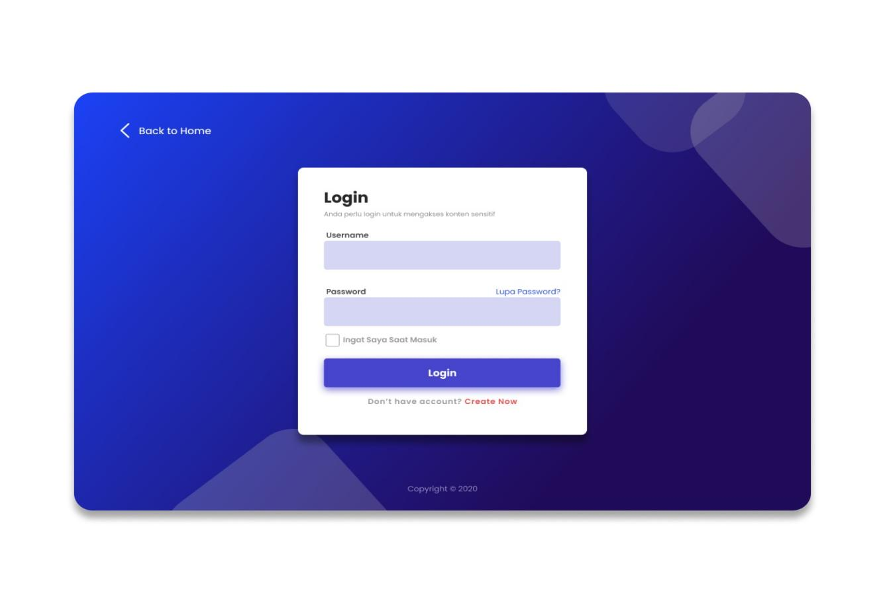

**SignUp Page:**

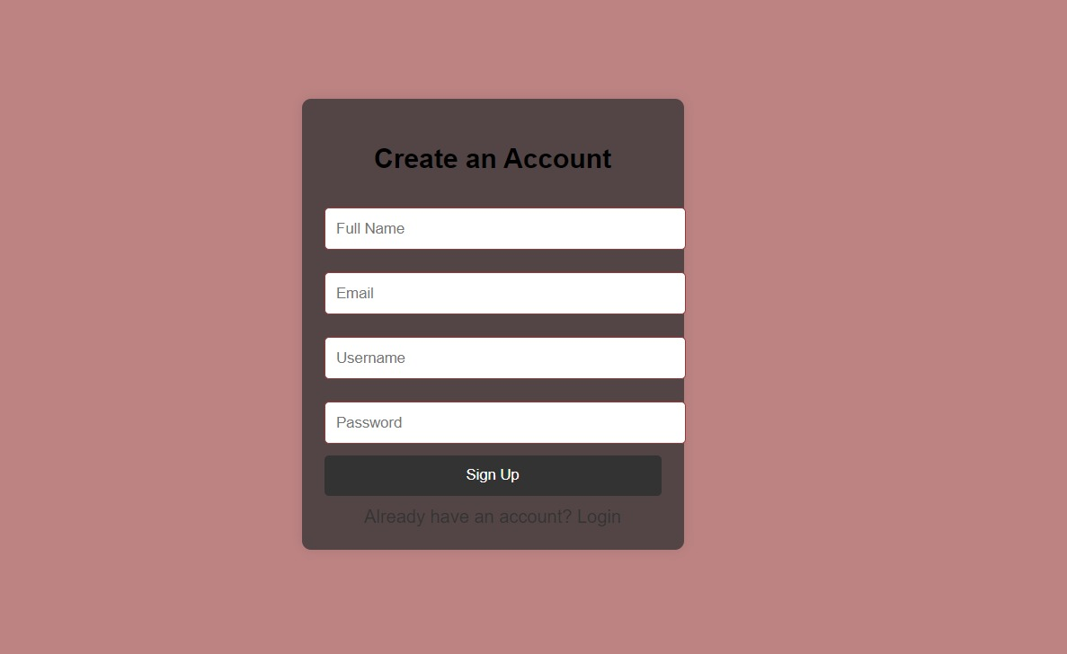

**Trainer Page:**

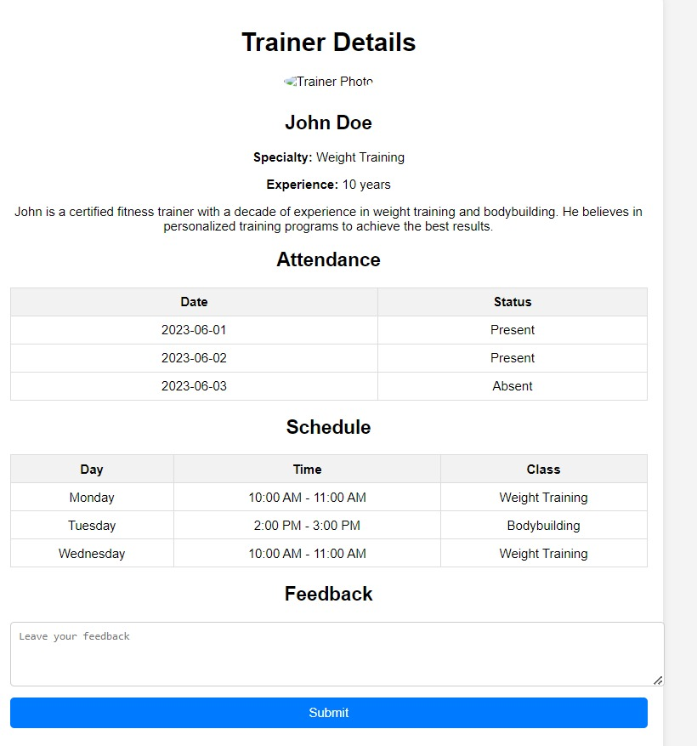

**Member Page:**

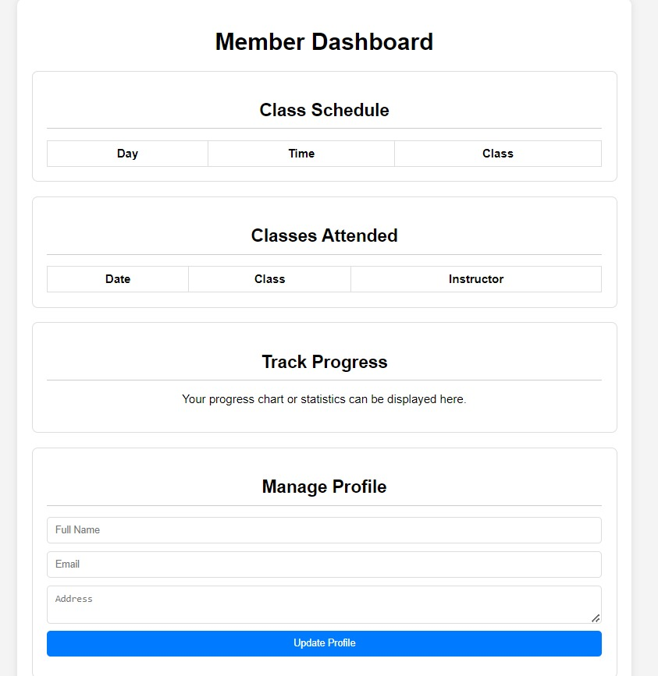

**Payment Page:**

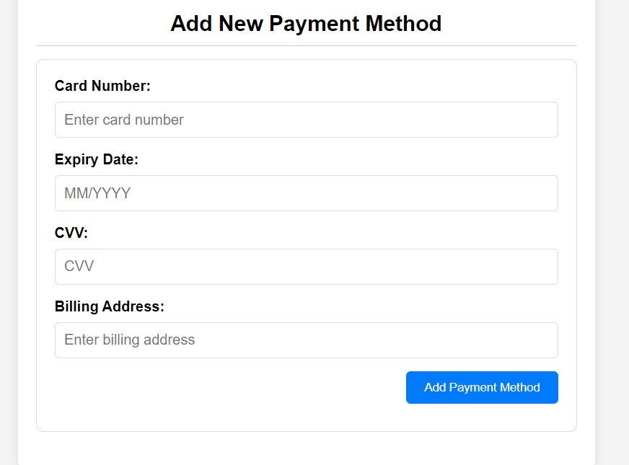

**Manage Profile:**

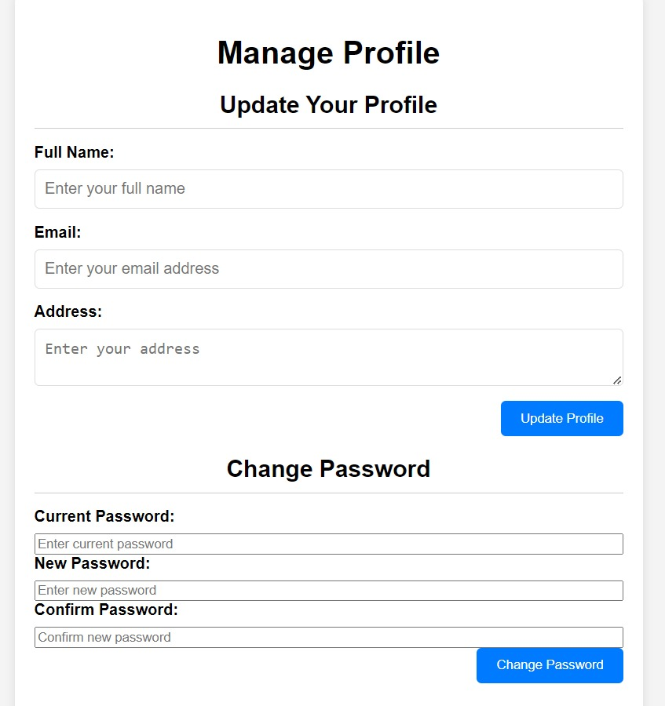

**CONCLUSION:**

In conclusion, developing a gym management system website using HTML involves a systematic approach to integrating various functional modules into a cohesive software solution. By leveraging HTML's structure and layout capabilities, alongside CSS for styling and JavaScript for dynamic interactions, you can create a user-friendly and responsive platform.

Key components such as membership management, class scheduling, payment processing, staff management, and reporting can be encapsulated in separate HTML pages or components. These elements, when combined with backend technologies for data processing and storage, enable robust functionality and seamless user experiences.

Ultimately, a well-designed gym management system website not only facilitates efficient operation management but also enhances member engagement and satisfaction. It serves as a valuable tool for both administrators and members, streamlining processes and promoting a thriving gym community.

**REFERENCES:**

**1**.**"Web Development and Design Foundations with HTML5"** by Terry Felke-Morris** - This textbook covers the fundamentals of web development, including HTML5, CSS, and JavaScript, which are essential for building the front-end of your website.

**2**.**"Learning Web Design: A Beginner's Guide to HTML, CSS, JavaScript, and Web Graphics"** by Jennifer Niederst Robbins - This book provides a comprehensive introduction to web design and development, focusing on HTML, CSS, and JavaScript, with practical examples and exercises.

**3**.**"Designing Data-Intensive Applications: The Big Ideas Behind Reliable, Scalable, and Maintainable Systems"** by Martin Kleppmann - This book explores the principles of designing robust and scalable backend systems, which can be beneficial when integrating databases and handling data for a gym management system.

**4**.**"Building Web Applications with HTML5, CSS3, and JavaScript: An Introduction to HTML5"** by Christian Hur and Maria P. Canton - This resource offers practical guidance on building modern web applications using HTML5, CSS3, and JavaScript, focusing on front-end development techniques.

**5.Online Documentation and Tutorials:** Websites like MDN Web Docs (developer.mozilla.org), W3Schools (w3schools.com), and Stack Overflow (stackoverflow.com) provide extensive documentation, tutorials, and community-driven insights on HTML, CSS, JavaScript, and web development best practices.